Project Development Phase
The development of the OptiCrop: Smart Agricultural Production Optimization Engine was carried out in a systematic and structured manner using the Software Development Life Cycle (SDLC). Each phase focused on ensuring the system was accurate, reliable, and user-friendly.

Phase 1: Problem Identification
The first step was to identify the challenges faced by farmers in selecting the most suitable crop for cultivation. Traditional farming methods often rely on experience and assumptions, which can lead to poor crop selection and reduced agricultural productivity. The objective was to develop a machine learning-based solution capable of providing accurate crop recommendations using soil and environmental data.

Phase 2: Requirement Analysis

1. Programming Language

Python
- Purpose: Core programming language used for data analysis, machine learning model development, and backend implementation.
- Usage in OptiCrop:
  - Data preprocessing
  - Model training
  - Prediction generation
  - Flask API development

2. Machine Learning & Data Science Technologies

Scikit-learn
- Purpose: Machine learning library used for building and evaluating predictive models.
- Usage:
  - Classification algorithms
  - Train-test splitting
  - Feature scaling
  - Model evaluation
Algorithms Used:
- Logistic Regression
- K-Nearest Neighbors (KNN)
- Decision Tree Classifier
- Random Forest Classifier
- K-Means Clustering

Pandas
- Purpose: Data manipulation and analysis library.
- Usage:
  - Loading CSV datasets
  - Cleaning agricultural data
  - Performing statistical analysis

NumPy
- Purpose: Numerical computing library.
- Usage:
  - Array operations
  - Mathematical computations
  - Feature preparation for machine learning models

Matplotlib & Seaborn
- Purpose: Data visualization libraries.
- Usage:
  - Exploratory Data Analysis (EDA)
  - Correlation heatmaps
  - Statistical visualizations

Joblib
- Purpose: Model serialization library.
- Usage:
  - Saving trained crop prediction models
  - Saving feature scalers
  - Loading models during deployment

3. Backend Technologies

Flask
- Purpose: Lightweight Python web framework used to create the backend API.
- Usage:
  - Handling HTTP requests
  - Connecting frontend with machine learning model
  - Generating crop predictions
  - Returning JSON responses

4. Frontend Technologies

HTML5
- Purpose: Defines the structure of the user interface.
- Usage:
  - Creating crop prediction input forms
  - Displaying recommendation results

CSS3
- Purpose: Provides styling and visual design.
- Usage:
  - Responsive layouts
  - User-friendly interface design
  - Result message styling

JavaScript
- Purpose: Provides client-side interaction.
- Usage:
  - Capturing user inputs
  - Sending requests to Flask API
  - Updating prediction results dynamically

5. Development Tools

Visual Studio Code (VS Code)
- Purpose: Integrated Development Environment (IDE).
- Usage:
  - Writing Python scripts
  - Managing project files
  - Running Jupyter notebooks
  - Debugging applications

Jupyter Notebook
- Purpose: Interactive environment for data exploration and experimentation.
- Usage:
  - Exploratory Data Analysis (EDA)
  - Data visualization
  - Testing machine learning approaches

Git
- Purpose: Version control system.
- Usage:
  - Tracking project changes
  - Maintaining code history
  - Managing collaboration

6. Database & Data Storage

CSV Dataset
- Purpose: Stores historical agricultural records.
- Usage:
  - Contains soil parameters, weather conditions, and crop labels.
  - Used as training data for the machine learning model.
Dataset File:
Crop_recommendation.csv

Technology Stack Summary
Layer | Technology
Programming Language | Python
Data Processing | Pandas, NumPy
Data Visualization | Matplotlib, Seaborn
Machine Learning | Scikit-learn
Model Storage | Joblib
Backend Framework | Flask
Frontend | HTML5, CSS3, JavaScript
Development Environment | VS Code, Jupyter Notebook
Version Control | Git
Data Source | Crop Recommendation CSV Dataset

Functional Requirements
- Accept soil nutrient values (Nitrogen, Phosphorus, Potassium).
- Accept environmental parameters such as temperature, humidity, pH, and rainfall.
- Predict the most suitable crop using a trained machine learning model.
- Display the recommended crop through a web interface.

Non-Functional Requirements
- Fast prediction time.
- High prediction accuracy.
- Easy-to-use interface.
- Secure and reliable system performance.

Phase 3: Dataset Collection
Before training models, we must understand the role of data in Machine Learning.
A machine learning model has no innate human intelligence. It cannot guess whether a crop will grow well in a certain environment based on intuition. Instead, it relies entirely on historical evidence.
A dataset is a structured compilation of past historical records. In our case, the dataset contains details of 2,200 previous agricultural yields, each labeled with the crop that performed best under those specific conditions. The model acts like a student looking at past exams: it analyzes these historical records, learns which traits (such as high nitrogen levels or heavy monsoon rain) correlate with crop types, and uses those patterns to recommend crops to farmers in real-time.
In machine learning, we say “Garbage In, Garbage Out”. The accuracy and fairness of your model depend entirely on the quality and size of your dataset. If your dataset contains incorrect records or represents only one type of climate, your model will make poor decisions in production.
Dataset
For this project, we utilize a custom compiled dataset containing historical soil profiles and observed crop yields.

https://www.galatfamily.in/download/Crop_recommendation.csv
DOWNLOAD_DATASET_FROM_WEBSITE →
Place the downloaded Crop_recommendation.csv file inside your project’s data folder. The final path must be: opticrop/data/Crop_recommendation.csv

4.2 Dataset Columns Explained
The raw fields inside Crop_recommendation.csv are structured as follows:
- Soil Nutrient Profile (N-P-K Ratio):
  - N (Nitrogen): The nitrogen content ratio in the soil (mg/kg).
    - Biological role: Nitrogen acts as the “leaf builder,” helping plants grow healthy green foliage.
  - P (Phosphorous): The phosphorous content ratio in the soil (mg/kg).
    - Biological role: Phosphorous acts as the “root maker,” stimulating early root development and flowering.
  - K (Potassium): The potassium content ratio in the soil (mg/kg).
    - Biological role: Potassium acts as the “defense helper,” regulating cell processes, disease resistance, and water intake.
- Climate & Environment Metrics:
  - temperature: Air temperature in Celsius (°C).
  - humidity: Relative air humidity in percentage (%). High humidity reduces plant evaporation.
  - ph: The pH level of the soil, representing acidity or alkalinity (ranging from 0.0 to 14.0, where 7.0 is neutral).
  - rainfall: Total regional rainfall volume in millimeters (mm).
- Target Crop Label:
  - label: The crop that succeeded in these conditions (e.g. rice, maize, mango, banana, coffee).
  - 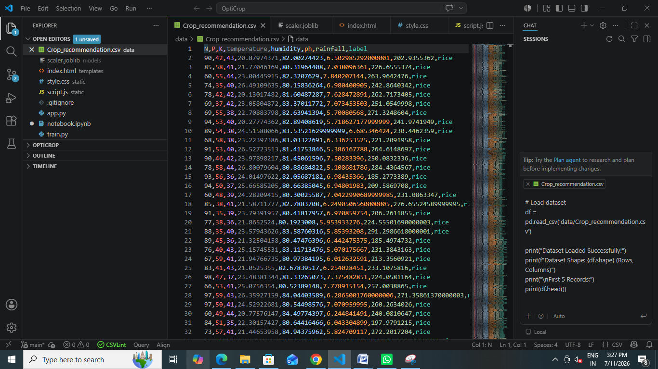

A crop recommendation dataset was collected containing agricultural records with the following features:
- Nitrogen (N)
- Phosphorus (P)
- Potassium (K)
- Temperature
- Humidity
- Soil pH
- Rainfall
- Crop Label (Target Variable)
The dataset served as the foundation for training and evaluating the machine learning models.

Phase 4: Data Preprocessing
The collected dataset was cleaned and prepared before model training.
The preprocessing activities included:
- Checking for missing values.
- Removing duplicate records.
- Verifying data consistency.
- Exploratory Data Analysis (EDA).
- Feature scaling using StandardScaler.
- Splitting the dataset into training and testing sets.
These steps improved the quality of the data and enhanced model performance.

Production Script - Model Comparison & Training (train.py)
We now transition from interactive notebook exploration to writing a production-grade Python script named train.py. While Jupyter is excellent for visual exploration (EDA) and prototype cleaning, standard Python scripts are preferred in production environments to run training pipelines from end to end and save the resulting model files.
6.1 Understanding Machine Learning Models & Algorithms
In this script, we train and compare four distinct classification models to find the one that balances accuracy with minority class detection:
- Logistic Regression: A linear model that estimates the probability of crop suitability scores. It is fast and simple.
- K-Nearest Neighbors (KNN): A distance-based classifier that looks at the 5 most similar historical soil records to vote on the crop.
- Decision Tree Classifier: A tree model that splits parameters recursively using simple True/False check paths.
- Random Forest Classifier: An ensemble model that builds 100 decision trees and averages their outputs. It is highly robust, handles non-linear relationships, and reduces variance.
- K-Means Clustering: An unsupervised learning algorithm that groups similar soil and weather profiles into 5 macro categories, helping researchers spot regional patterns without using labels.

Model Comparison Training Script (train.py)
Save this complete script as train.py in your project root folder:
import os
import pandas as pd
import numpy as np
from sklearn.model_selection import train_test_split
from sklearn.preprocessing import StandardScaler
from sklearn.linear_model import LogisticRegression
from sklearn.neighbors import KNeighborsClassifier
from sklearn.tree import DecisionTreeClassifier
from sklearn.ensemble import RandomForestClassifier
from sklearn.cluster import KMeans
from sklearn.metrics import accuracy_score, classification_report
import joblib

def run_training_pipeline():
print("Step 1: Loading agricultural dataset...")
df = pd.read_csv('data/Crop_recommendation.csv')

print("Step 2: Resolving missing values...")
# Fill any empty cells with median values
for col in df.columns[:-1]:
if df[col].isnull().sum() > 0:
df[col] = df[col].fillna(df[col].median())

# Split features and target
X = df.drop(columns=['label'])
y = df['label']

# Stratified split to keep crop proportions identical
X_train, X_test, y_train, y_test = train_test_split(X, y, test_size=0.2, random_state=42, stratify=y)

print("Step 3: Applying Standard Scaling to features...")
scaler = StandardScaler()
X_train_scaled = scaler.fit_transform(X_train)
X_test_scaled = scaler.transform(X_test)

print("\nStep 4: Training and comparing classification models...")
models = {
"Logistic Regression": LogisticRegression(max_iter=1500, random_state=42),
"K-Nearest Neighbors": KNeighborsClassifier(n_neighbors=5),
"Decision Tree": DecisionTreeClassifier(random_state=42),
"Random Forest": RandomForestClassifier(n_estimators=100, random_state=42)
}

best_acc = 0.0
best_model = None
best_model_name = ""

for name, clf in models.items():
# Fit classifier
clf.fit(X_train_scaled, y_train)
y_pred = clf.predict(X_test_scaled)

acc = accuracy_score(y_test, y_pred)
print(f"-> {name} Test Accuracy: {acc * 100:.2f}%")

if acc > best_acc:
best_acc = acc
best_model = clf
best_model_name = name

# Unsupervised K-Means clustering check
kmeans = KMeans(n_clusters=5, random_state=42, n_init=10)
kmeans.fit(X_train_scaled)
print("\nUnsupervised K-Means clustering completed on scaled features.")

print(f"\nWinner Selected: {best_model_name} with {best_acc * 100:.2f}% accuracy.")

# Print metrics report for the winner
winner_preds = best_model.predict(X_test_scaled)
print("\nWinner Performance Report:")
print(classification_report(y_test, winner_preds))

print("Step 5: Serializing and saving best model & scaler...")
os.makedirs('models', exist_ok=True)
joblib.dump(best_model, 'models/crop_model.joblib')
joblib.dump(scaler, 'models/scaler.joblib')
print("✓ Output model: models/crop_model.joblib")
print("✓ Output scaler: models/scaler.joblib")

if __name__ == '__main__':
run_training_pipeline()
COPY

6.2 Executing the Training Script
- Open your project terminal and run:
- python train.py

Phase 5: Model Development
Several machine learning algorithms were implemented and compared to identify the best-performing model.
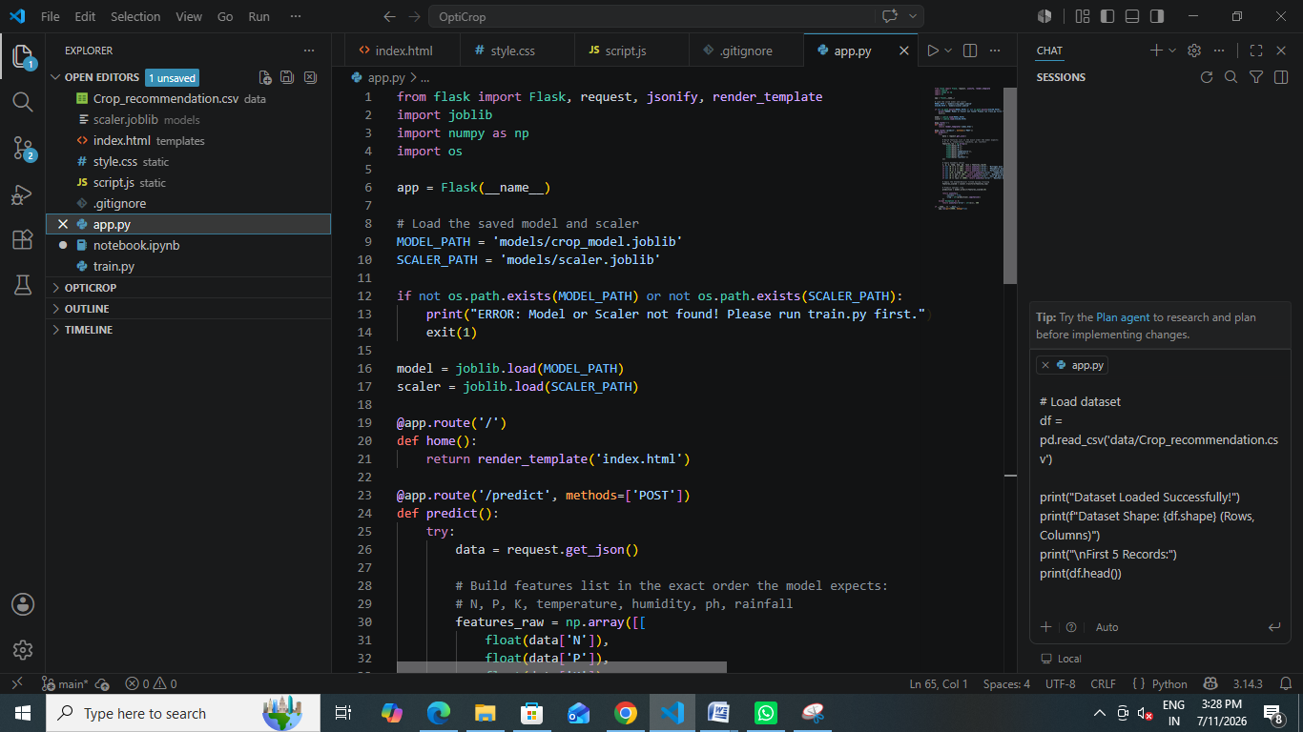
The models evaluated included:
- Decision Tree Classifier
- Random Forest Classifier
- K-Nearest Neighbors (KNN)
- Support Vector Machine (SVM)
- Logistic Regression
- Naïve Bayes
Each model was trained using the processed dataset and evaluated based on prediction accuracy and overall performance.

Phase 6: Model Evaluation
The trained models were tested using the test dataset.
Performance evaluation included:
- Accuracy Score
- Confusion Matrix
- Classification Report
- Cross-Validation (where applicable)
The model with the highest accuracy and consistent performance was selected as the final prediction model.

Phase 7: Model Saving
The selected machine learning model and preprocessing scaler were saved using the Joblib library.
Saved files included:
- crop_model.joblib
- scaler.joblib
Saving the model allowed it to be loaded directly by the web application without retraining.

Phase 8: Web Application Development
A web-based application was developed using Flask.
The application consists of:
- Backend developed in Python using Flask.
- Frontend created using HTML, CSS, and JavaScript.
- Form-based input for soil and weather parameters.
- Prediction module integrated with the trained machine learning model.
- Result page displaying the recommended crop.
Frontend User Interface Files
To create a clean interface, we split our frontend assets into three files: index.html, style.css, and script.js.
8.1 How the Frontend Connects with the Backend
Web applications operate on a Client-Server Architecture.
- The Client (Frontend): This is the user interface running in the browser (index.html, style.css, script.js). Its job is to collect information from the user and display results.
- The Server (Backend): This is our Flask script (app.py) running on our local machine. It listens for incoming HTTP requests, feeds features to our machine learning model, and returns the prediction.
- The Communication (HTTP POST & JSON): When the user clicks the submit button, the frontend does not reload the page. Instead, JavaScript packages the form inputs into a JSON dictionary and sends it via an HTTP POST request to the /predict URL on the Flask server. Once the server responds with a success or rejection state, the webpage updates itself dynamically.
- Why split into HTML, CSS, and JS?: We separate structure (HTML), style (CSS), and behavior (JavaScript) to maintain clean code. This follows the Separation of Concerns principle, making it easy to redesign the UI or tweak frontend validations without editing backend code.

Frontend Template (templates/index.html)
Save this layout configuration inside templates/index.html:
<!DOCTYPE html>
<html lang="en">
<head>
<meta charset="UTF-8">
<meta name="viewport" content="width=device-width, initial-scale=1.0">
<title>OptiCrop Recommendation Engine</title>
<link rel="stylesheet" href="/static/style.css">
</head>
<body>
<div class="card">
<h2 class="title">OptiCrop Recommendation Engine</h2>
<p class="subtitle">Enter soil and climate variables to identify the optimal crop.</p>

<form id="predictionForm">
<div class="row">
<div class="col">
<label for="N">Nitrogen (N) - mg/kg</label>
<input type="number" step="any" id="N" required placeholder="0 - 250">
</div>
<div class="col">
<label for="P">Phosphorus (P) - mg/kg</label>
<input type="number" step="any" id="P" required placeholder="0 - 250">
</div>
<div class="col">
<label for="K">Potassium (K) - mg/kg</label>
<input type="number" step="any" id="K" required placeholder="0 - 300">
</div>
</div>

<div class="row">
<div class="col">
<label for="temperature">Temperature (°C)</label>
<input type="number" step="any" id="temperature" required placeholder="e.g. 24.5">
</div>
<div class="col">
<label for="humidity">Humidity (%)</label>
<input type="number" step="any" id="humidity" required placeholder="e.g. 78">
</div>
</div>

<div class="row">
<div class="col">
<label for="ph">Soil pH Level</label>
<input type="number" step="any" id="ph" required placeholder="0.0 - 14.0">
</div>
<div class="col">
<label for="rainfall">Rainfall (mm)</label>
<input type="number" step="any" id="rainfall" required placeholder="e.g. 180">
</div>
</div>

<button type="submit">Identify Best Crop</button>
</form>

<div id="result"></div>
</div>
<script src="/static/script.js"></script>
</body>
</html>
COPY

Style Sheet (static/style.css)
Save this CSS configuration inside static/style.css to build our form wrapper:
body {
background-color: #0c0c0e;
color: #f3f4f6;
font-family: system-ui, -apple-system, sans-serif;
display: flex;
justify-content: center;
align-items: center;
min-height: 100vh;
margin: 0;
padding: 20px;
}
.card {
background-color: #16161a;
border: 1px solid #2e2e38;
padding: 40px;
border-radius: 16px;
max-width: 500px;
width: 100%;
}
.title {
margin: 0 0 8px 0;
font-size: 24px;
font-weight: 700;
}
.subtitle {
margin: 0 0 30px 0;
color: #9ca3af;
font-size: 14px;
}
.row {
display: flex;
gap: 16px;
margin-bottom: 20px;
}
.col {
display: flex;
flex-direction: column;
flex: 1;
}
label {
font-size: 12px;
font-weight: 600;
text-transform: uppercase;
letter-spacing: 0.5px;
margin-bottom: 6px;
color: #9ca3af;
}
input {
background-color: #24242e;
border: 1px solid #3a3a46;
padding: 12px;
border-radius: 8px;
color: white;
font-size: 14px;
outline: none;
}
input:focus {
border-color: #10b981;
}
button {
background-color: #10b981;
color: white;
border: none;
padding: 14px;
border-radius: 8px;
font-weight: 700;
width: 100%;
cursor: pointer;
font-size: 14px;
transition: background-color 0.2s;
}
button:hover {
background-color: #059669;
}
#result {
margin-top: 24px;
padding: 16px;
border-radius: 8px;
text-align: center;
font-weight: 700;
font-size: 18px;
display: none;
}
.success {
background-color: rgba(16, 185, 129, 0.1);
border: 1px solid #10b981;
color: #10b981;
display: block !important;
}
.error {
background-color: rgba(239, 68, 68, 0.1);
border: 1px solid #ef4444;
color: #ef4444;
display: block !important;
}
COPY

Application Logic Script (static/script.js)
Save this JS module inside static/script.js:
document.getElementById('predictionForm').addEventListener('submit', async (e) => {
e.preventDefault();

// Package form parameters
const data = {
N: parseFloat(document.getElementById('N').value),
P: parseFloat(document.getElementById('P').value),
K: parseFloat(document.getElementById('K').value),
temperature: parseFloat(document.getElementById('temperature').value),
humidity: parseFloat(document.getElementById('humidity').value),
ph: parseFloat(document.getElementById('ph').value),
rainfall: parseFloat(document.getElementById('rainfall').value)
};

const resultBox = document.getElementById('result');
resultBox.style.display = 'block';
resultBox.className = '';
resultBox.innerText = 'Analyzing soil parameters...';

try {
const response = await fetch('/predict', {
method: 'POST',
headers: { 'Content-Type': 'application/json' },
body: JSON.stringify(data)
});

const res = await response.json();

if (response.ok && res.success) {
resultBox.className = 'success';
resultBox.innerText = `RECOMMENDED CROP: ${res.crop}`;
} else {
resultBox.className = 'error';
resultBox.innerText = `Prediction Error: ${res.error || 'Server rejection'}`;
}
} catch (err) {
resultBox.className = 'error';
resultBox.innerText = `Connection failed: ${err.message}`;
}
});

Phase 9: System Testing

Understanding the Script Execution
Let’s break down the logic of this script:
- e.preventDefault(): Prevents the browser from reloading the page when you click the submit button. This allows us to handle the form processing silently in the background.
- data: Gathers all values from form fields (e.g. N, P, K, temperature) and formats them into a single JavaScript object using parseFloat(). The keys in this object match the keys in our Python request parser inside app.py.
- fetch('/predict', ...): Starts a secure asynchronous HTTP connection. It sends the payload to our backend server as a JSON string (JSON.stringify(data)) with headers identifying the content type.
- response.json(): Waits for the server to reply and parses the returned JSON string back into a readable JavaScript dictionary.
- Result Banner Update: Displays the #result container and applies the appropriate CSS styles. If the response succeeds, it displays the recommended crop name in a green success banner; if it fails, it displays a red warning banner.

8.3 Executing the Model Training Script
Before our server can process predictions, we must generate our serialized model and scaler weights:
- Open your terminal in the root of your opticrop directory.
- Execute the training pipeline:
- python train.py
COPY
- Inspect the Console Outputs: You will see step-by-step progress as Scikit-Learn cleans headers, splits train/test subsets, applies standard scaling, compares accuracies, selects the winner, and confirms serialization:
- Step 1: Loading agricultural dataset...
- Step 2: Resolving missing values...
- Step 3: Applying Standard Scaling to features...

- Step 4: Training and comparing classification models...
- -> Logistic Regression Test Accuracy: 96.59%
- -> K-Nearest Neighbors Test Accuracy: 97.95%
- -> Decision Tree Test Accuracy: 98.64%
- -> Random Forest Test Accuracy: 99.32%

- Unsupervised K-Means clustering completed on scaled features.

- Winner Selected: Random Forest with 99.32% accuracy.

- Step 5: Serializing and saving best model & scaler...
- ✓ Output model: models/crop_model.joblib
- ✓ Output scaler: models/scaler.joblib
COPY
- Verify Output Files: Confirm that crop_model.joblib and scaler.joblib have been successfully created inside your models/ directory.

8.4 Running the Flask Web Server
With the model weights and all frontend/backend files created, we can spin up our local development web server:
- Rerun the Flask server in your terminal:
- python app.py
COPY
- Confirm Server Initialization: The console will output:
- Crop model and scaler loaded successfully!
- * Serving Flask app 'app'
- * Debug mode: on
- * Running on http://127.0.0.1:5000
COPY
- Access the Portal: Open your web browser and navigate to:
- http://localhost:5000
COPY
You should see your newly created Crop Recommendation form displayed.

8.5 Manual Verification & Test Scenarios
To test that your machine learning model and web interface are communicating correctly, try inputting this validation profile:
- Test Scenario 1: Optimal Rice Soil Profile
  - Nitrogen (N): 90
  - Phosphorus (P): 42
  - Potassium (K): 43
  - Temperature: 21
  - Humidity: 82
  - pH: 6.5
  - Rainfall: 200
  - Expected Result: RECOMMENDED CROP: Rice displays in a green success box.
- Test Scenario 2: High-Risk Out-of-Bounds Input
  - Enter a pH value of 15.0.
  - Click Identify Best Crop.
  - Expected Result: Prediction Error: Soil pH must be between 0.0 and 14.0. displays in a red warning box, proving that our Flask API validation checks are actively defending the machine learning pipeline from garbage inputs!
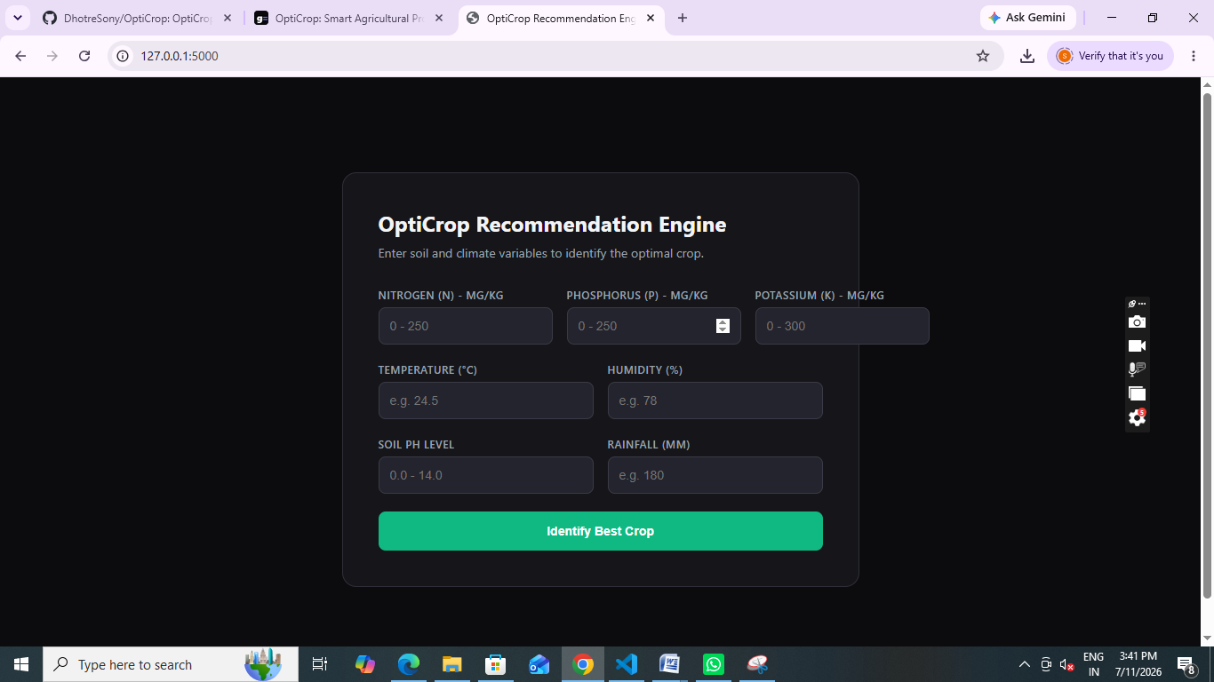

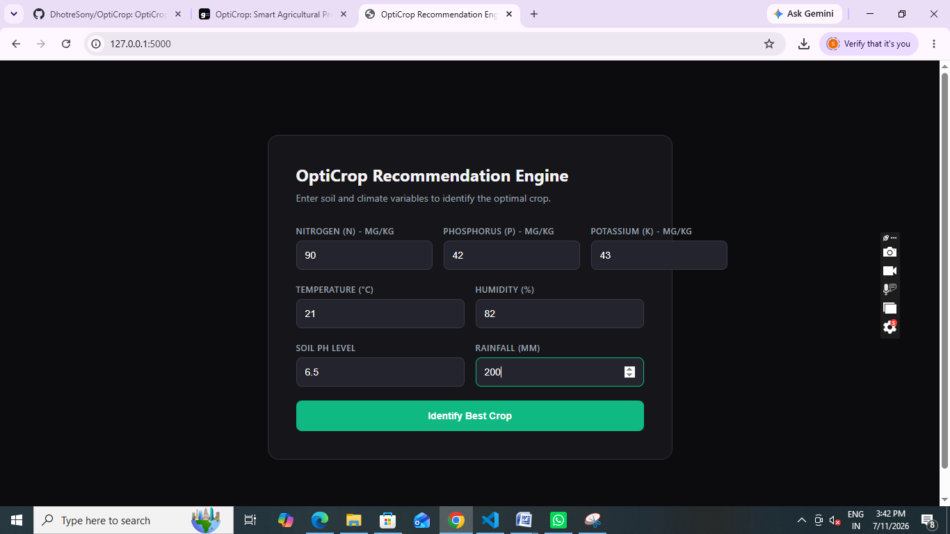

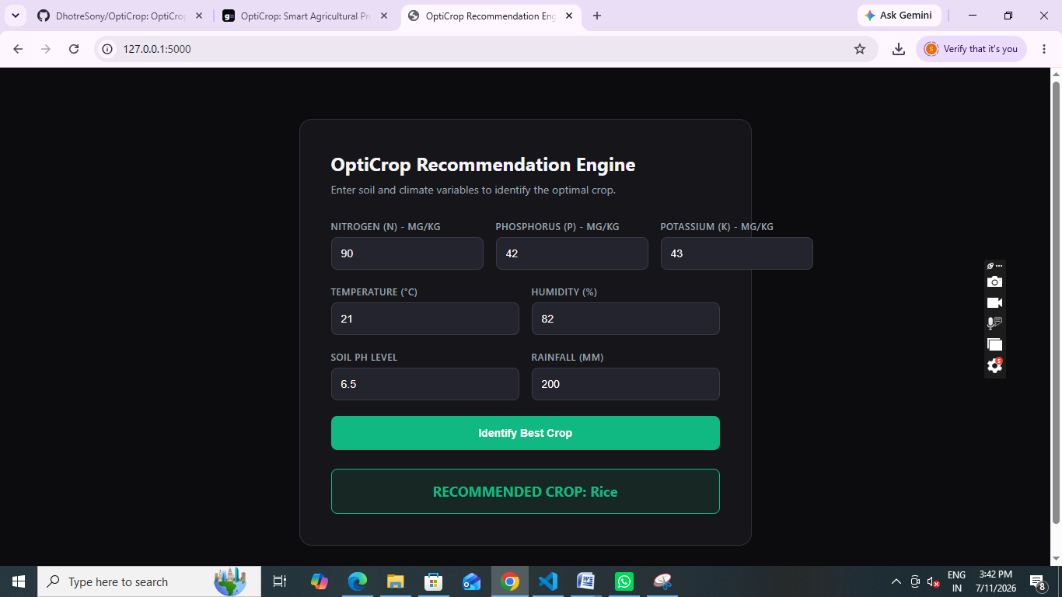

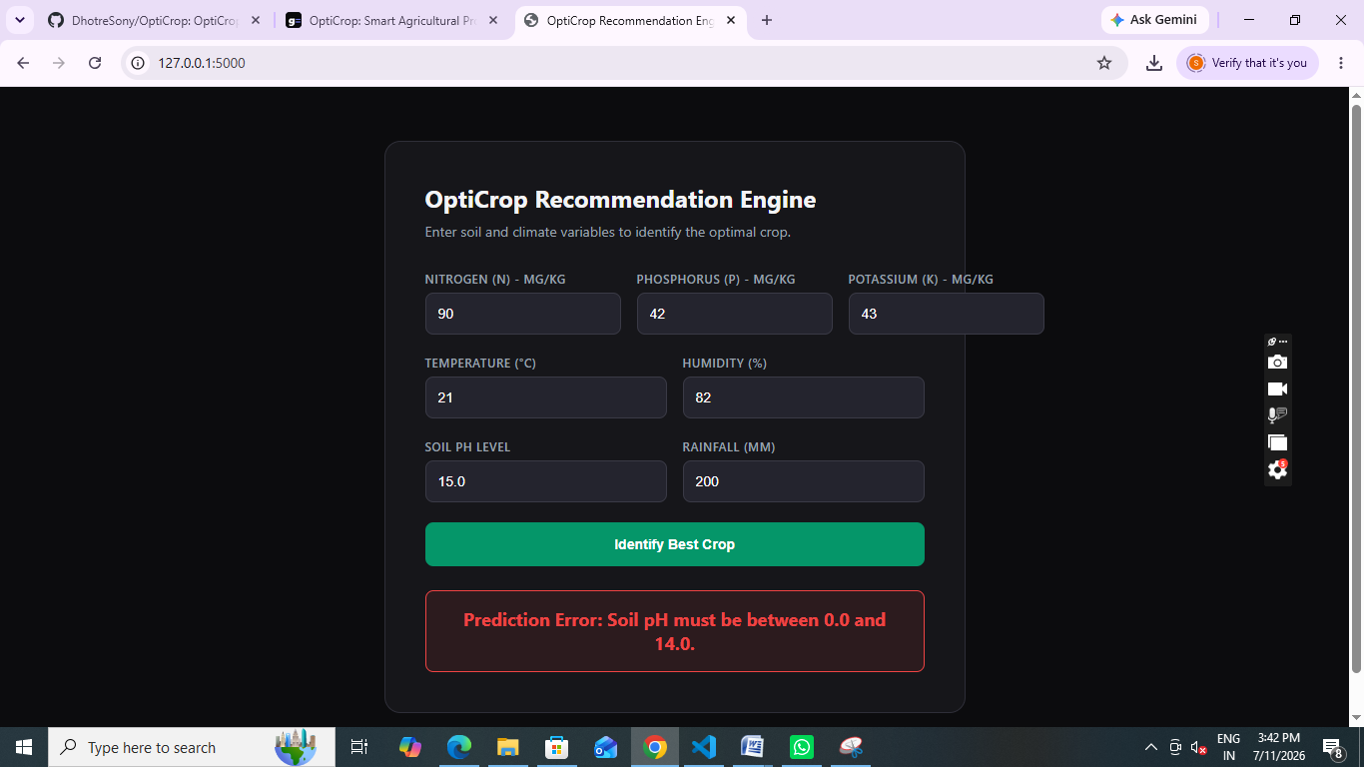

Phase 10: Deployment
The finalized application was deployed on a local development server. The trained machine learning model was integrated with the Flask application to provide real-time crop recommendations based on user input.








Development Workflow
The complete development process followed the sequence below:
- Problem Identification
- Requirement Analysis
- Dataset Collection
- Data Preprocessing
- Exploratory Data Analysis (EDA)
- Feature Scaling
- Machine Learning Model Training
- Model Evaluation and Comparison
- Save Best Model
- Flask Application Development
- Frontend Design
- System Testing
- Deployment
- Final Documentation

